**Assignment : DHCP**

**Computer Networking**

**Tanmay Dureja (td1391)**

1. **The leases files to verify that Ubuntu has obtained an IP address.**

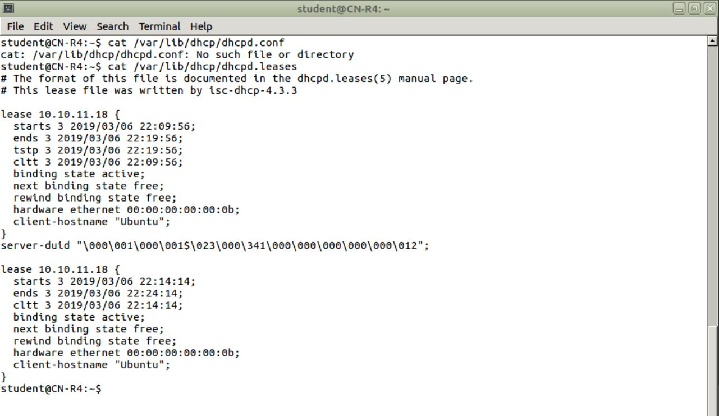

Capture 1 Lease Files from R4

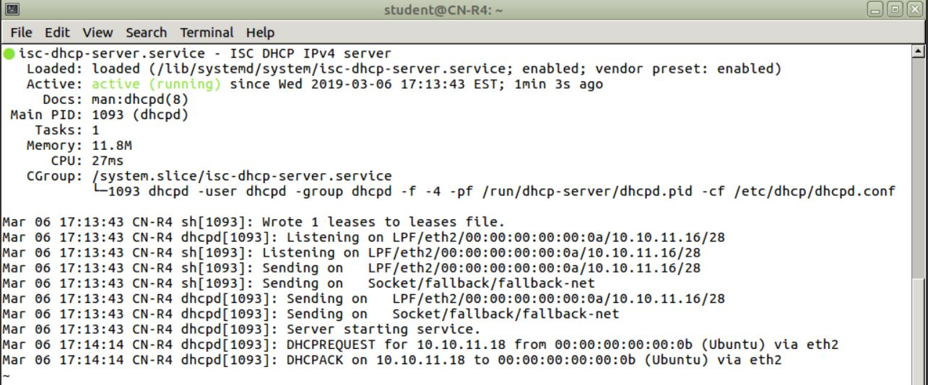

Capture 2 DHCP Address allotment

1. **Your configuration for the DHCP server.**

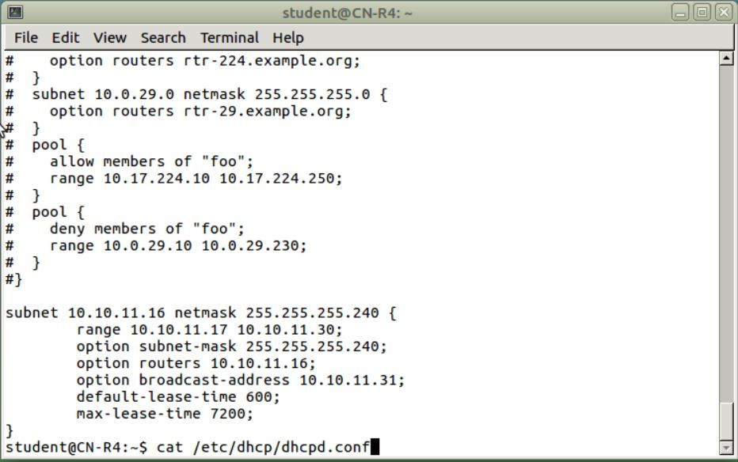

Capture 3 Config File

1. **Screenshots of ifconfig on Ubuntu**

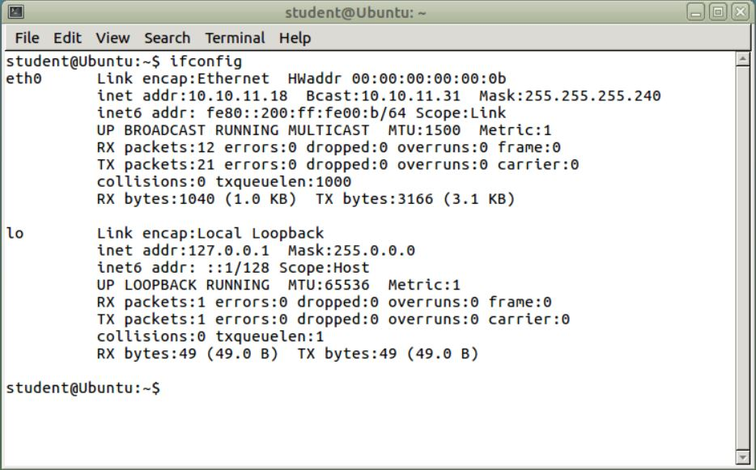

Capture 4 IfConfig Ubuntu

1. **Screenshots showing Ubuntu pinging R4**

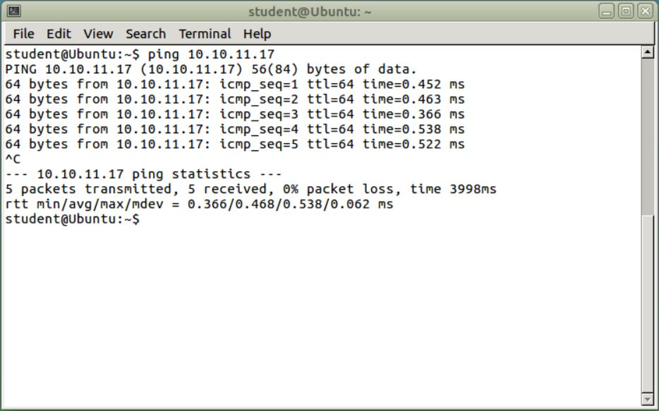

Capture 5 Ubuntu Pinging R4